Resilient Agriculture for Inclusive and Sustainable Ethiopian Food Systems

Report Food Safety Workshop
Addis Ababa, 6 December 2023
Compiled by
Getenesh Alemayehu, Helen Getaw, Abebe Ayelign, Tewodros Tafera & Dawit Alemu

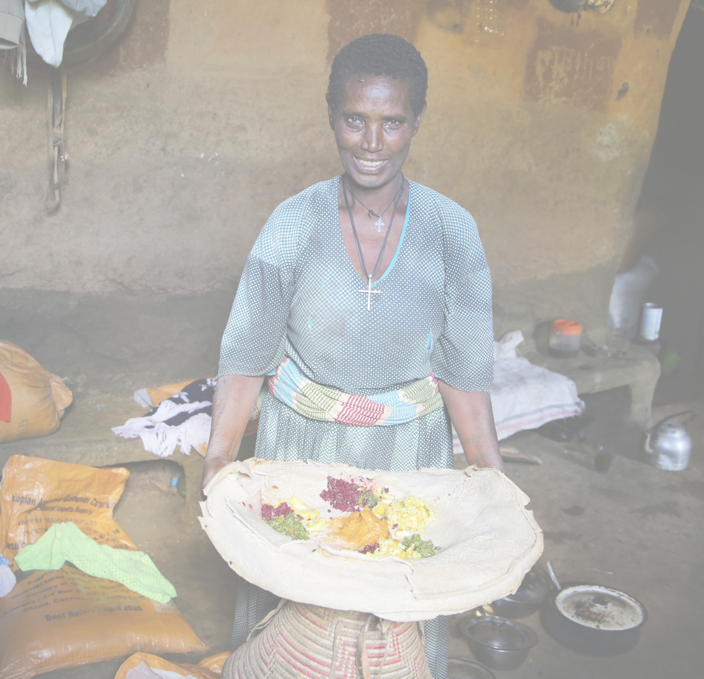
Stichting Wageningen Research Ethiopia


Introduction
Food safety and quality are an integral part of food security, public health and economic development. An efficient food safety system is therefore essential to protect the general public food borne hazards (microbial, chemical or physical) and the negative health effects that go along with it. Additionally, it can support a nation's economy by boosting agricultural exports. Many public policy instruments have been put into place by nations to direct their governments in creating frameworks for assuring the safety of food. "Ensure the safety and quality of foods from farm- to- table" was one of the policy objectives of Ethiopia's food and nutrition policy. Accordingly, it is crucial to create a system for guaranteeing food safety and quality utilizing a thorough and integrated farm-to-table strategy in which all value chain participants play crucial roles. However, ensuring food safety remains a significant issue in Ethiopia.
To be successful and sustainable, initiatives to improve capacity in national food safety and quality must be based on a careful identification, analysis and prioritization of needs. Moreover, the identification of needs tends to be a complex process that is often influenced by diverse factors including competing priorities, competition for resources or inadequate information. An efficient food safety system which is evidence based is therefore essential to protect the general public from contaminated food and the negative health effects that go along with it. This brief presents the key challenges and opportunities prevailing in the country to ensure food safety along with key stakeholders that are engaged in the process, the extent of their alignment and coordination and what needs to be done in addressing the identified challenges for improved national food safety system.

Overview of Ethiopian food safety system
The Food and Nutrition Policy (2018) addresses food safety. One of the objectives concerns improving the safety and quality of food throughout the value chain. The Ethiopia food safety governance system is vested on three ministries that have the legal mandate to implement Ethiopian food and nutrition policy, namely the Ministry of Health, Ministry of Agriculture, and the Ministry of Trade and Regional Integration, organized in the National Food and Nutrition Council which also oversees the national-level implementation of food safety. At regional, zonal, woreda and kebele level a similar structure exists to oversee food and nutrition including food safety. Given that the Food and Nutrition council mainly focuses on food and nutrition, the attention given to address food safety challenges is inadequate.
The assessment of regulations and standards that govern food safety systems are outdated and fragmented across several governing bodies. Under the current arrangements several ministries and independent executive bodies share the responsibility to manage food safety. Multi-agency system governance requires a strong coordination mechanism to avoid duplication of effort and addressing the food safety related issue effectively. Ensuring that the safety of food is a shared responsibility requires strong synergy with clear lines of authority, mandates and accountability.
The results of the assessment indicate that there is sufficient constitutional and policy provision for food safety in Ethiopia. However, it is recognized that the responsibility for food safety regulations, compliance, and inspection in Ethiopia is fragmented and disjointed across different ministries and executive governing bodies. Food safety authorities are distributed among several Ministries – most notably, the Ethiopian Food and Drug Authority within the Ministry of Health, the Ministry of Trade and Regional Integration, and the Ministry of Agriculture – as well as their respective regional offices, local authorities, and municipalities.

Figure 1. The National Food & Nutrition Council
National Food and Nutrition Council

Led by the Prime Minister
Ministry of Health
Ministry of Agriculture
Ministry of Trade and Regional Integration
- Ethiopian Food and Drug Authority
- Ethiopian Public Health institute
- Pharmaceutical Supply Agency
- Ethiopian Standard Agency
- Food, Beverage, and Pharmaceutical Industry Development Institute
- Meat and Dairy Industry Development institute
- Ethiopian Trade Competition and Consumer Protection Authority
- Ethiopian Agricultural authority
- Veterinary Drug and Animal Feed Administration and Control Agency
- National Animal Health Diagnostic and Investigation Centre
- National Veterinary Institute

Food safety assessment
RAISE-FS issued a study to:
- Assess all 5 pillars of the national food safety system in general
- Food control system
- Food laws and regulations
- Food inspection and certification
- Monitoring and surveillance (official food control laboratories)
- Information, education, communication and training

- Identify the current challenges with regard to food safety in the aforementioned sectors in the domestic and export markets along the 5 pillars.
The study generated primary data by engaging 19 relevant stakeholders (government, NGOS and the private sector), complemented by a desk review of policy documents and literature. The generated data were synthesized to identify prevailing challenges and opportunities in ensuring food safety covering the five key pillars of food safety systems, namely (i) food control management, (ii) food law and regulations, (iii) inspection and certification, (iv) official food control laboratory, and (v) information, education, communication and training. The assessment focused on selected commodities, namely poultry, potato, pulses, oilseeds, herbs and spices and covering primary production, processing and domestic and international markets. The results were validated in a workshop representing 13 organizations, to identify which actions need to be taken for a coordinated effort to address emerging challenges and facilitating cross-institutional learning and interactions for food safety transformation.

Key-challenges of the national food safety system
The purpose of the workshop were to:
- To validate food safety control system assessment findings (see box)
- To enrich assessment findings focused on food control management, food law and regulation, inspection and certification, official food laboratories and information education and communication

The participants prioritized the following under each pillar.
Pillar 1: FOOD CONTROL SYSTEM
- Lack of coordination and transparency of stakeholders
- Arrangement of institutional setup and fragmented work activities
- Overlap of mandates among institutions
- lack of market-oriented production and controlling system
- Lack of traceability
- No promotion i.e. no food safety based incentives
- Inadequacy and lack of law/regulations,
- Lack of enforcement and acts
- Public dominated system i.e., week private engagement
- Institutional insatiability and week operational system
- Lack of capacity including manpower and technologies
- Lack of awareness from top to bottom- government to community
- Lack of attention by higher officials
- Inadequate research on the issue
Pillar 2: FOOD LAW AND REGULATIONS
- Lack of a national food safety law to manage legal matters related to food safety
- Lack of mandatory food safety standards (chicken meat and egg, mycotoxin standards for poultry feed, potato, spices and herbs)
- Majority of the proclamations are outdated ( E.g meat inspection proclamation)
- The food and nutrition policy doesn’t clearly indicate clear delineation of testing and certifying agents to avoid conflict of interest
- The food and nutrition policy lacks to put mechanisms of coordination among mandated actors
Pillar 3: - Inspection and certification
- Regulators have no authority to inspect informal market areas
- No regulation and law enforcement for poultry slaughtering
- No strong inspection and regulation system in the perspectives of specific food value chains
- Regulatory mandates on inspection overlap between Ethiopian Agricultural Authority and Ethiopia Food and Drug Authority.
- Inadequate institutional arrangements and limited coordination all legally mandated food safety inspection sectors
Pillar 4: Official food control laboratory
- Limited knowledge of biomedical engineers to maintain the lab equipment
- Lack of availabilities of lab consumables, reagents, chemicals and spare parts
- Lack of collaboration to access and use lab facilities
- Limited access for exact specifications to purchase lab equipment
- Limited number of accredited labs
Pillar 5: INFORMATION, EDUCATION, COMMUNICATION AND TRANING
- Limited food safety awareness at all stage throughout the value chain
- Limited risk communication platform and poor coordination
- Limited media coverage of food safety
- Limited food safety curriculum

Mechanism to address the key challenges
There is no integrated coordination mechanism to clarify overlaps or gaps in food safety regulations and implementation in Ethiopia. The fragmentation of regulatory authorities across ministries was observed in compliance and inspection activities. A lack of adequate capacity in food safety best practices (e.g., Good Agricultural Practices, Good Hygienic Practices, and Hazard Analysis Critical Control Point best practices) has led to reduced supervisory competence and low levels of food safety expertise in the regulatory authorities. Given the complex nature of food safety and the pervasive nature of the problem in Ethiopia, the effective mechanism to address the identified challenges in the respective pillars of the national food safety system in a dynamic manner is the establishment of an experts’ platform composed of representatives from relevant institutions and sectors. Accordingly, during the consultative workshop (6 December 2022), an expert platform was established composed of 11 experts from ten organizations.
Recognizing the complexity of ensuring food safety associated with the need to engage diverse stakeholders, revisiting policies, regulations and directives, along with building adequate awareness and enforcement mechanisms, the established national platform is expected to regularly engage to further prioritize identified key challenges, explore designing interventions options, and engage with relevant policy makers and organizations for uptake and mainstreaming of the suggested interventions.

The expert platform
Ethiopia Food and Drug Authority
Ministry of Agriculture
Ethiopia Agriculture Authority
Ethiopia Conformity Assessment
Ethiopian Public Health Institute
Addis Ababa University
Alliance of Bioversity International and CIAT
Ethiopian Institute of Agricultural Research
H.A.E Spices Baltina Plc
Stichting Wageningen Research Ethiopia (Secretariat)

For more information contact: info.raisefsethiopia@gmail.com

https://www.nipn.ephi.gov.et/sites/default/files/2020-05/Food%20and%20Nutrition%20Policy.pdf
Source: Global Alliance for Improved Nutrition https://www.gainhealth.org/resources/reports-and-publications/review-food-safety-policy-ethiopia

